**1**

**INTRODUCTION**

In today’s fast-moving world, providing quick and helpful customer support is very important. One common challenge for support teams is assigning incoming tickets to the right people. When ticket assignment is done manually or without clear rules, it can cause delays, mistakes, and slow customer service.

Making ticket assignment faster and more organized helps teams work better. It ensures tickets go to the right agents quickly, based on their skills and availability. Using automated routing and smart rules can improve response times, make teams more productive, and help solve customer problems faster.

**Project overview:**

1. This project aims to improve how support teams handle and assign incoming tickets.
2. Currently, manual ticket assignment can lead to delays mistakes, and frustrated customers.
3. By streamlining the process, tickets will be automatically sent to the right agents.
4. This ensures faster responses and better use of team skills and time
5. The project will use rules, automation, and smart workflows to manage assignments.
6. It will help balance workloads and reduce pressure on individual team members.
7. As a result, customers will receive quicker and more accurate Support
8. Overall, the project will make support operations more efficient and reliable

**Purpose:**

The purpose of this project is to make ticket assignment faster and easier for support teams. Many companies still assign tickets manually, which can cause delays, mistakes, and slow service. This project will help by automatically sending each ticket to the right agent based on their skills and workload.

It will make sure tickets are handled quickly and fairly, so no agent is too busy while others have less work. Automatic ticket assignment will help the team work better and solve customer problems faster. In the end, this project will create a smoother support process and improve customer service.

# IDEATION PHASE

**Problem statement:**

ABC Corporation, a leading technology company, was facing challenges with efficiently assigning support tickets to the appropriate teams. With a vast array of products and services, the support team found it increasingly difficult to manually route tickets to the right groups, leading to delays in issue resolution and customer dissatisfaction.

**Objective:**

The objective of this initiative is to implement an automated system for ticket routing at ABC Corporation, aimed at improving operational efficiency by accurately assigning support tickets to the appropriate teams. This solution aims to reduce delays in issue resolution, enhance customer satisfaction, and optimize resource utilization within the support department.

1. The system will quickly route tickets to the right teams, helping to solve issues faster and reduce waiting time.
2. It will improve customer satisfaction by ensuring that customers get faster and more accurate responses to their problems.
3. The automated system will help balance workloads among support teams, making better use of available staff and resources.

# REQUIREMENT ANALYSIS

**Solution Requirement:**

|  |  |
| --- | --- |
| Date |  |
| Team id | NM2025TMID05625 |
| Project name | Streamlining ticket assignment for efficient support operations |
| Maximum marks |  |

**Functional requirements:**

Following are the functional requirements of the proposed solution

|  |  |  |
| --- | --- | --- |
| **FR NO.** | **Functional requirements(milestones)** | **Sub requirements**  **(sub milestones)** |
| FR-1 | USERS | Create Users create users (manne niranjan and Katherine pierce) |
| FR-2 | GROUPS | Create Groups. create groups  (certificates and platform group) |
| FR-3 | ROLES | Create Roles create Roles (certificates role and platform role) |
| FR-4 | TABLE | Create Table create table (operations related) and add the data |
| FR-5 | ASSIGN ROLES&USER  GROUPS | * Assign roles & users to Certificate group * Assign roles & users to platform group |
| FR-6 | ASSIGN ROLE TO TABLE | Assign role to table add group members and roles |
| FR-7 | CREATE ACL | Create ACL insert new roles in read the write operations |
| FR-8 | FLOW | * Create a Flow to Assign operation & Ticket group * Create a Flow to Assign operation & Ticket to platform group |
| FR-9 | CONCLUSION | Streamlining Ticket Assignment in service now improves support operations |

**Non-functional Requirements:**

Following are the non-functional Requirements of proposed solution

|  |  |  |
| --- | --- | --- |
| **FR NO.** | **NON-FUNCTIONAL**  **REQUIREMENTS** | **DESCRIPTION** |
| NFR-1 | USABILITY | makes support operations faster by sending each issue to the right team quickly. It helps reduce mistakes by matching tickets with the right experts. |
| NFR-2 | SECURITY | helps keep support data secure by limiting who can see and handle each ticket. This protects customer privacy and builds trust in the support process. |
| NFR-3 | RELIABILITY | ensures tickets are consistently directed to the right teams, reducing errors and delays. This reliability helps support teams solve issues faster and more effectively |
| NFR-4 | PERFORMANCE | improves performance by speeding up how quickly issues reach the right  team. This leads to faster problem resolution and better overall support efficiency. |
| NFR-5 | AVAILABILITY | Streamlining ticket assignment ensures support teams are always ready to handle incoming issues without delay. This improves availability and helps customers get help whenever they need it. |
| NFR-6 | SCALABILITY | allows the support system to handle more requests as the company grows. This makes it easy to add new teams and manage higher ticket volumes without slowing down. |

**Data flow Diagram:**

**USERS**

**GROUPS**

## ROLES

**TABLES**

**ASSIGN ROLES**

**&USERS TO GROUP**

**ASSIGN ROLE TO**

**TABLE**

**CREATE ACL**

## FLOW

**Technology stack:**

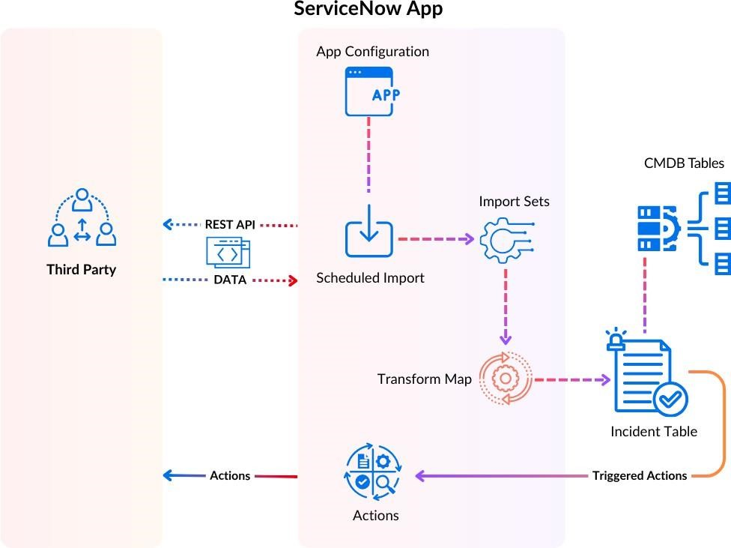

**PROJECT DESIGN:**

**Proposed solution:**

|  |  |  |
| --- | --- | --- |
| **SI.NO** | **PARAMETER** | **DISCRIPTION** |
| 1 | Problem statement (problem to be solved ) | Manual ticket assignment is slow and inefficient, causing delays and lower customer satisfaction. We need a faster, automated way to assign tickets to the right support agents based on their skills, workload, and ticket priority. |
| 2 | Idea/solution description | Use an automated ticket assignment system that quickly matches incoming tickets to the right support agents based on their skills, availability, and ticket priority. This will speed up response times, balance workloads, and improve customer satisfaction |
| 3 | Noveity/uniqueness | The unique aspect of this solution is the smart, automated matching of tickets to agents using real-time data like skills, workload, and ticket priority. Unlike basic assignment methods, it can adapt instantly to changes, ensuring faster, fairer, and more accurate ticket distribution. |
| 4 | Social impact/customer satisfaction | helps customers get faster, more accurate support, which increases their  satisfaction and trust in the service. It also reduces stress and overload for support agents, creating a better work environment and improving overall team performance. |
| 5 | Business model/revenue model) | The solution can be offered as a subscription-based software (SaaS), where businesses pay monthly or yearly fees based on the number of users or tickets handled. Additional revenue can come from premium features like advanced reporting, AI-based routing, and system customization. |
| 6 | scalability of the solution | The solution can easily grow with the business by handling more tickets, agents, and support teams without losing speed or accuracy. It can be used by small teams or large organizations and can integrate with existing support tools to support future expansion. |

**STREAMLINING TICKET ASSIGNMENT FOR EFFICIENT SUPPORT OPERATIONS**

**MILESTONE -1 USERS**

**ACTIVITY 1:create Users**

**PURPOSE:**

User creation helps set up profiles for support agents with their skills, availability, and roles. This makes it easier to quickly assign tickets to the right person, improving support speed and customer satisfaction.

**USES**

User creation saves key details about each support agent, like their skills and availability. This helps the system quickly assign tickets to the right agent, making support faster and more efficient

.

**STEPS:**

1. Open service now.
2. Click on All >> search for user
3. Select Users under system security
4. Click on new
5. Fill the following details to create a new user
6. Click on submit

Create one more user

1. Create another user with the following details
2. Click on submit

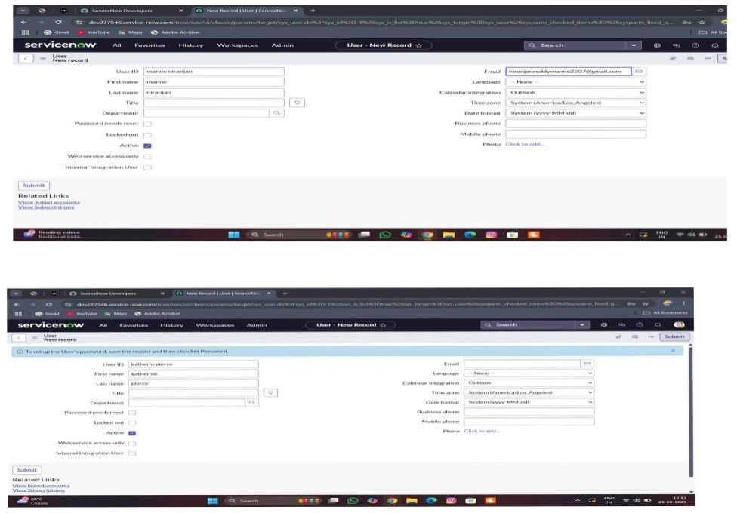

**MILESTONE -2 GROUPS**

**ACTIVITY 1: create Groups**

**PURPOSE:**

Group creation helps organize support agents into teams based on their skills, departments, or ticket types. This makes

it easier to assign tickets to the right team, improving ticket handling speed and ensuring the right experts work on the right issues.

**USES:**

Group creation helps organize support agents into teams based on skills or departments. This makes it easier to quickly

assign tickets to the right team, improving support speed, workload balance, and overall efficiency.

**STEPS:**

1. Open service now.
2. Click on All >> search for groups
3. Select groups under system security
4. Click on new
5. Fill the following details to create a new group
6. click on submit

Create one more Group

1. Create another group with the following details
2. Click on submit

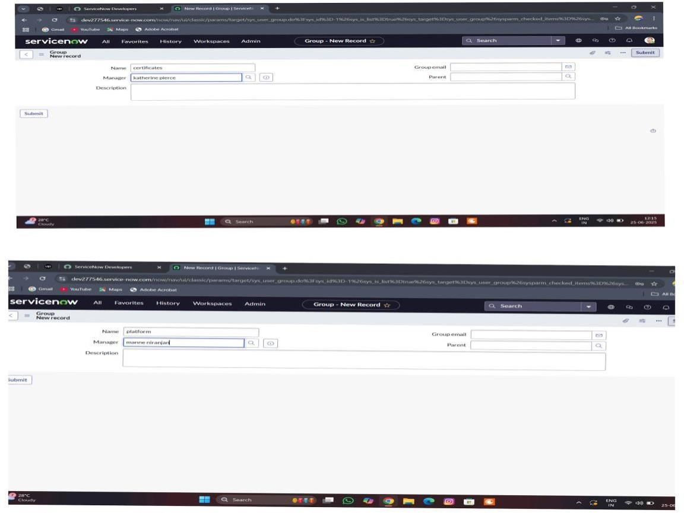

**MILESTONE -3 ROLES**

**ACTIVITY 1: Create Roles**

**PURPOSE:**

Roles creation defines what each user can do in the system, such as managing tickets, handling specific tasks, or overseeing teams. It helps control access, organize responsibilities, and ensure the right people have the right permissions to keep the support process smooth and secure.

**USES:**

Roles creation helps assign specific permissions and responsibilities to each user. It ensures that agents, team leads, and managers can only access the features they need, making the ticket assignment process organized, secure, and efficient.

**STEPS:**

1. Open service now
2. Click on All >> search for roles
3. Select roles under system security
4. Click on new
5. Fill the following details to create a new role
6. Click on submit Create one more role
7. Create another role with the following details
8. click on submit

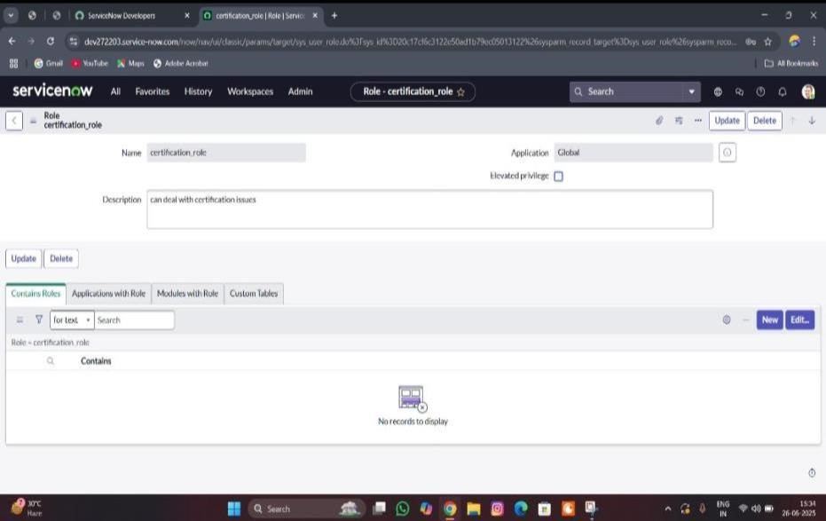

**MILESTONE -4 TABLE**

**ACTIVITY-1 Creating Table**

**PURPOSE:**

Table creation is used to store, organize, and display important data like user details, ticket information, groups, and

roles in a clear and structured way. This helps the system easily manage and track tickets, making the assignment process faster, more accurate, and easier to control.

**USES:**

Table creation helps store and organize data like users, tickets, groups, and roles. It makes it easy to manage, track, and quickly assign tickets to the right agents or teams.

**STEPS:**

1. Open service now.
2. Click on All >> search for tables
3. Select tables under system definition
4. Click on new
5. Fill the following details to create a new table

Label : Operations related

Check the boxes Create module & Create mobile module

1. Under new menu name : Operations related
2. Under table columns give the columns
3. Click on submit

Create choices for the issue filed by using form design

Choices are

*unable to login to platform

* 404 error

*regarding certificates

*regarding user expired

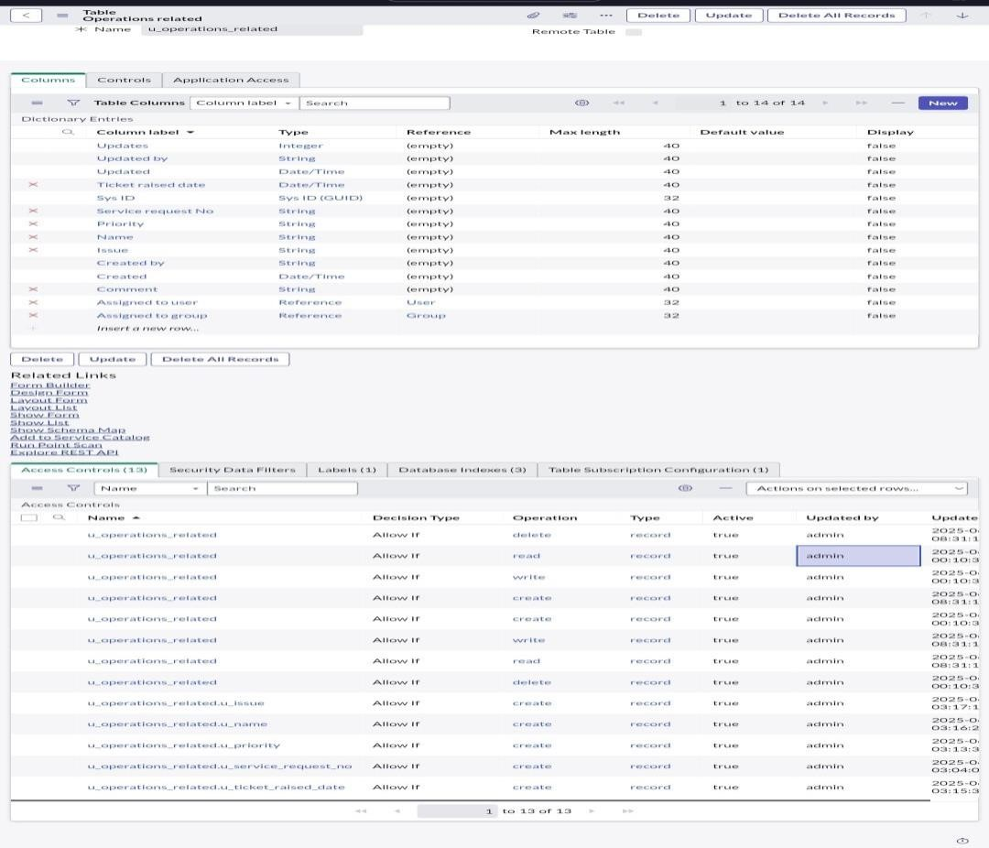

**MILESTONE -5 ASSIGN ROLES & USERS TO GROUP**

**ACTIVITY-1 Assign roles & users to certificate group**

**PURPOSE:**

Assigning roles and users to a certificate group helps make sure the right people handle the right tickets. It

ensures tickets go to qualified agents quickly and safely.

**USES:**

It helps the system automatically send specific tickets to the right certified agents or teams, making ticket assignment faster, more accurate, and handled by qualified people.

**STEPS:**

1. Open service now.
2. Click on All >> search for tables
3. Select tables under system definition
4. Select the certificates group
5. Under group members
6. Click on edit
7. Select Katherine Pierce and save
8. Click on roles
9. Select Certification_role and save

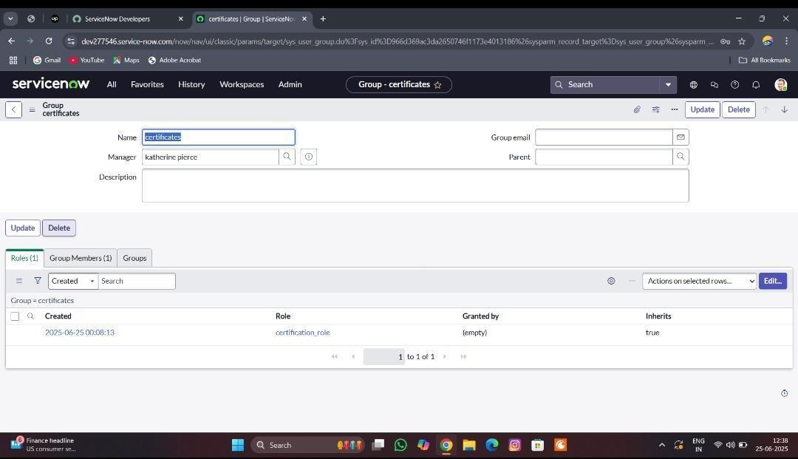

**ACTIVITY -2 Assign roles & users to platform group**

**PURPOSE:**

Assigning roles and users to a platform group helps organize agents based on the platforms or tools they support. This ensures tickets related to specific platforms are quickly assigned to the right experts, improving accuracy and response time

**USES:**

It helps the system automatically send platform-specific tickets to the right agents who are trained for that platform, making ticket assignment faster, more accurate, and efficient.

T shirt

**STEPS:**

* 1. Open service now.
  2. Click on All >> search for tables
  3. Select tables under system definition
  4. Select the platform group
  5. Under group members
  6. Click on edit
  7. Select Manne Niranjan and save
  8. Click on role
  9. give platform role and save

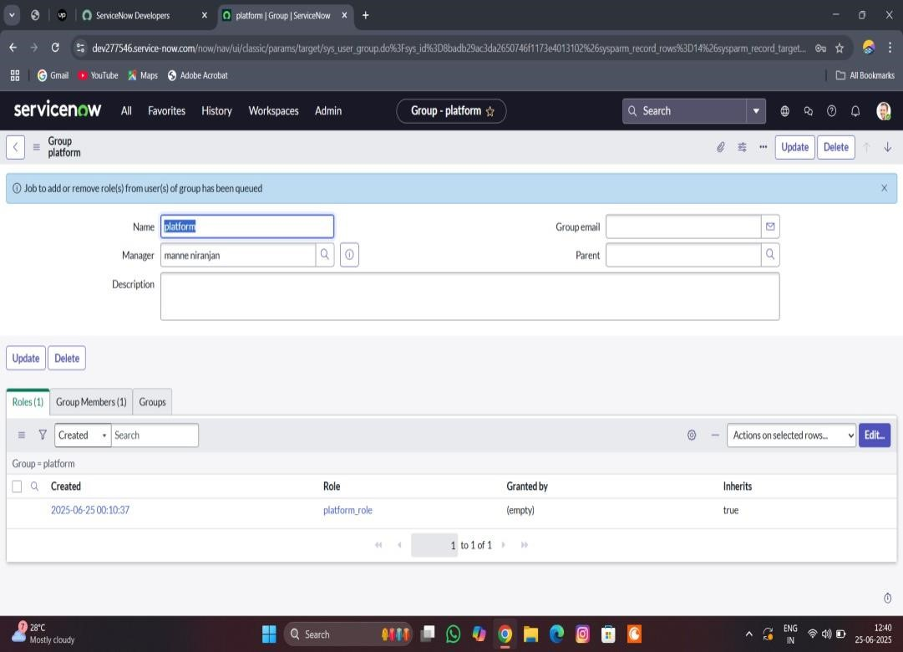

**MILESTONE-6 ASSIGN ROLE TO TABLE**

**ACTIVITY-1 Assign role to table**

**PURPOSE:**

Assigning roles to a table helps control who can view, edit, or manage the information in that table. It ensures that only the right users with proper permissions can access or update ticket, user, or group data, keeping the system organized, secure, and efficient.

**USES:**

It controls who can see or update the table data, making sure only the right people can manage tickets, users, or groups. This keeps the ticket assignment process safe, organized, and efficient.

**STEPS:**

1. Open service now.
2. Click on All >> search for tables
3. Select operations related table
4. Click on the Application Access
5. Click on u_operations_related read operation
6. Click on the profile on top right side
7. Click on elevate role
8. Click on security admin and click on update
9. Under Requires role
10. Double click on insert a new row
11. Give platform role
12. And add certificate role
13. Click on update
14. Click on u_operations_related write operation
15. Under Requires role
16. Double click on insert a new row
17. Give platform role
18. And add certificate role

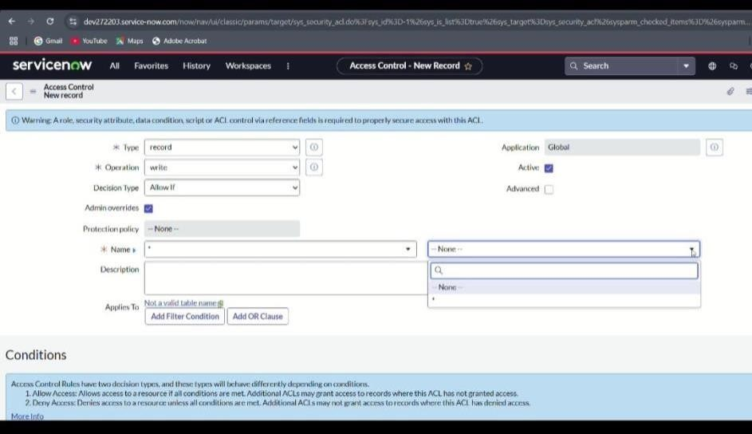

**MILESTONE-7 CREATE ACL**

**ACTIVITY-1 Create ACL**

**PURPOSE:**

Creating an ACL (Access Control List) helps set rules about who can view, create, edit, or delete specific data. This

keeps the ticket assignment process secure by making sure only authorized users can access or change important information.

**USES:**

Creating an ACL helps control user access to tickets, tables, and other system data. It makes sure only the right people can view or update information, keeping the ticket assignment process secure and well-managed.

**STEPS:**

1. Open service now.
2. Click on All >> search for ACL
3. Select Access Control(ACL) under system security
4. Click on new
5. Fill the following details to create a new ACL
6. Scroll down under requires role
7. Double click on insert a new row
8. Give admin role
9. Click on submit
10. Similarly create 4 acl for the following fields

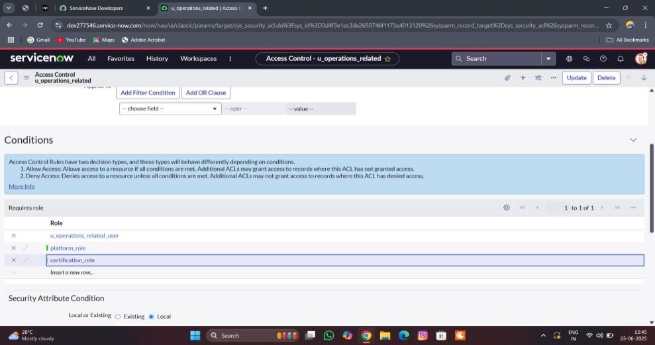

**MILESTONE -8 FLOW**

**ACTIVITY-1 Create a Flow to Assign operations ticket to group**

**PURPOSE:**

Purpose of Creating a Flow to Assign Operations Ticket to Group: The purpose is to automate the process of directing operations-related tickets to the right support group.

**USES:**

It automatically routes operations tickets to the correct group, speeding up ticket handling and improving support efficiency.

**STEPS:**

1. Open service now.
2. Click on All >> search for Flow Designer
3. Click on Flow Designer under Process Automation.
4. After opening Flow Designer Click on new and select Flow.
5. Under Flow properties Give Flow Name as “ Regarding Certificate”.
6. Application should be Global.
7. Select Run user as “ System user ” from that choice.
8. Click on Submit.

1. Click on Add a trigger
2. Select the trigger in that Search for “create or update a record” and select that.
3. Give the table name as “ Operations related ”.
4. Give the Condition as

Field : issue

Operator : is

Value : Regrading Certificates 5. After that click on Done

1. Now under Actions.
2. Click on Add an action.
3. Select action in that search for “ Update Record ”.
4. In Record field drag the fields from the data navigation from left side
5. Table will be auto assigned after that
6. Give the field as “ Assigned to group ” 12. Give value as “ Certificates ”
7. Click on Done.
8. Click on Save to save the Flow.
9. Click on Activate.

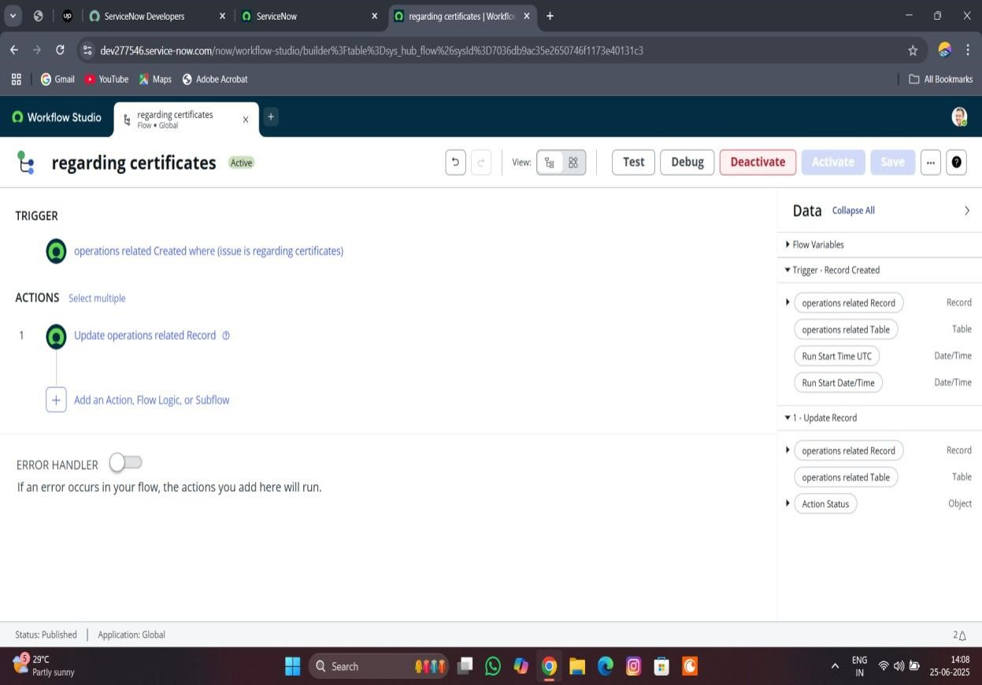

**ACTIVITY-2 Create a Flow to Assign operations ticket to Platform**

**PURPOSE:**

To automatically assign operations tickets to the right platform experts, ensuring faster and accurate support.

**USES:**

It routes operations tickets to the correct platform specialists automatically, improving response time and support accurate

**STEPS:**

1. Open service now.
2. Click on All >> search for Flow Designer
3. Click on Flow Designer under Process Automation.
4. After opening Flow Designer Click on new and select Flow.
5. Under Flow properties Give Flow Name as “ Regarding Platform ”.
6. Application should be Global.
7. Select Run user as “ System user ” from that choice.
8. Click on Submit.

1. Click on Add a trigger
2. Select the trigger in that Search for “create or update a record” and select that.
3. Give the table name as “ Operations related ”.
4. Give the Condition as

Field : issue

Operator : is

Value : Unable to login to platform

1. Click on New Criteria

Field : issue

Operator : is

Value : 404 Error

1. Click on New Criteria

Field : issue

Operator : is

Value : Regrading User expired

1. After that click on Done.
2. Now under Actions.
3. Click on Add an action.
4. Select action in that search for “ Update Record ”.
5. In Record field drag the fields from the data navigation from left side
6. Table will be auto assigned after that
7. Give the field as “ Assigned to group ”. 14. Give value as “ Platform ”
8. Click on Done.
9. Click on Save to save the Flow.
10. Click on Activate.

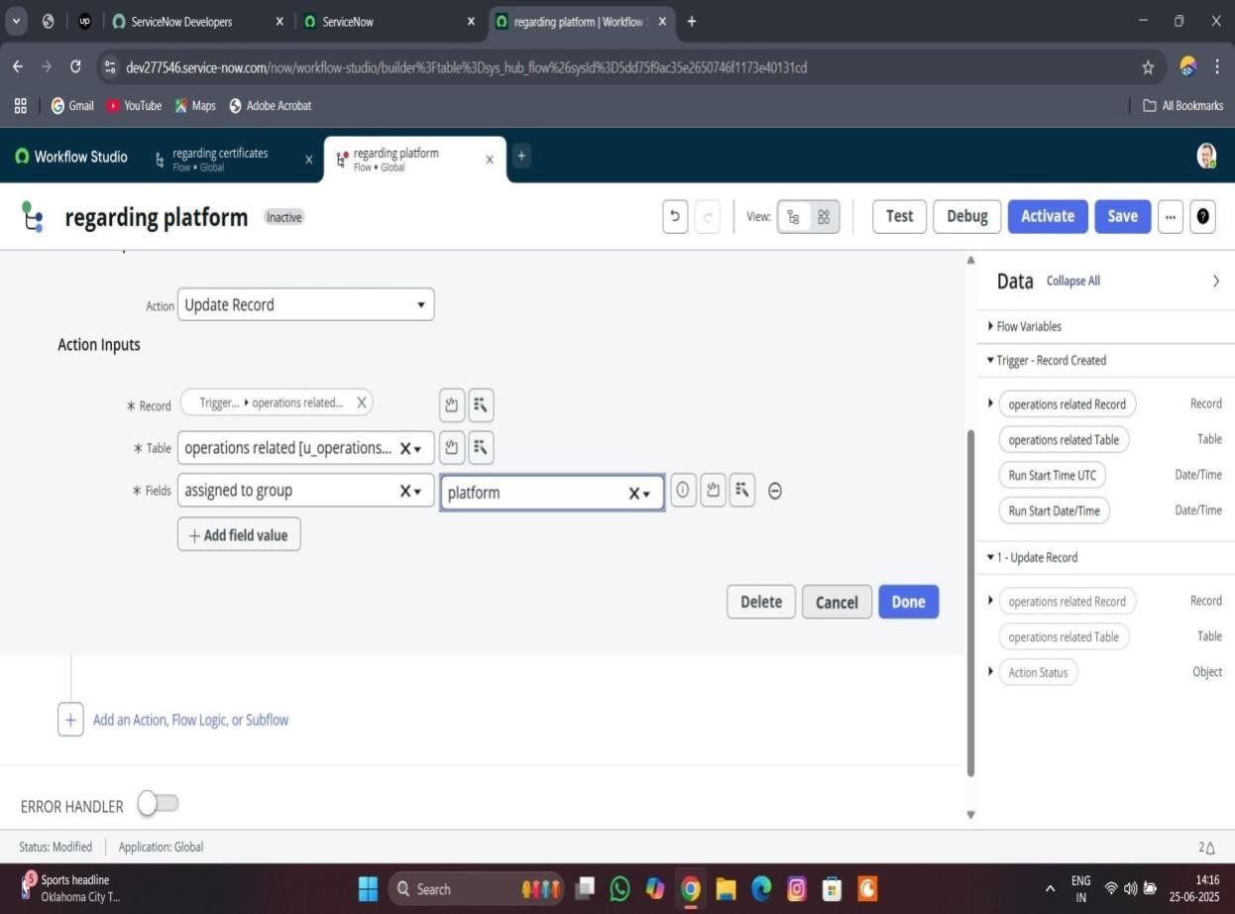

**PROJECT PLANNING & SCHEDULING:**

Assigned task to the group members are shown below

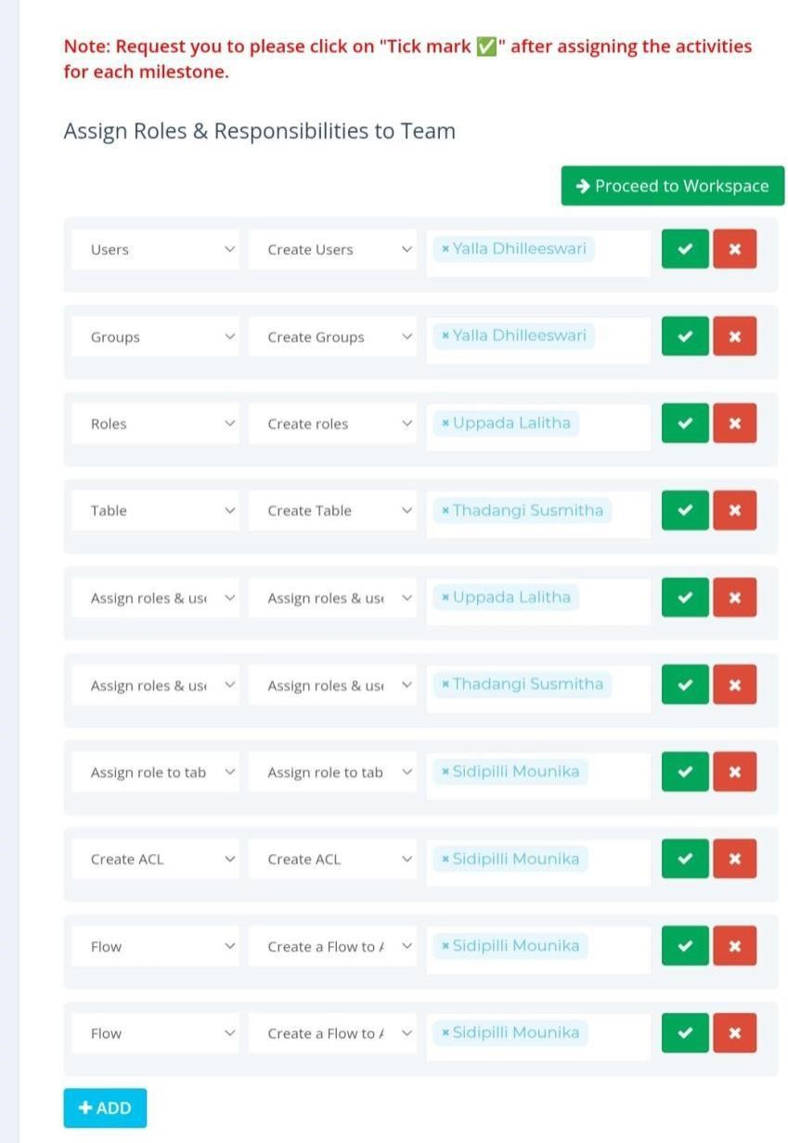

|  |  |  |  |
| --- | --- | --- | --- |
| **Functional requirements** | **User story** | **No.of**  **activiti es** | **Team members** |
| Users | As an admin,I want to create user profiles with details like name, skills, availability, and role,So that the system can automatically assign tickets to the right support agents quickly and accurately. | 1 | Y.dhilleeswari |
| Groups | As an admin,I want to create groups based on skills, departments, or ticket types,So that tickets can be quickly assigned to the right team for faster and more efficient support. | 1 | Y.dhilleeswari |
| Roles | As an admin,I want to create roles with specific permissions and responsibilities,So that users can access only the features and data they need to perform their tasks efficiently and securely. | 1 | U.lalitha |
| Tables | As an admin,I want to create tables to store and organize data like users, groups, roles, and tickets,So that the system can easily manage and quickly access the information needed for efficient ticket assignment. | 1 | T.susmitha |
| Assign roles & users to groups | As an admin,I want to assign specific roles and users to appropriate groups,So that tickets can be automatically routed to the right teams and handled by qualified agents quickly and efficiently. | 2 | U.lalitha |
| Assign role to table | As an admin,I want to assign specific roles to tables,So that only authorized users can view, edit, or manage the data, ensuring secure and organized ticket assignment operations. | 1 | T.susmitha |
| Create ACL | As an admin,I want to create Access Control Lists (ACLs) that define who can access or modify different parts of the system,So that ticket assignment and support data remain secure and only authorized users can make changes | 1 | S.Mounika |
| Flow | As an admin,I want to create automated workflows that guide how tickets are assigned and processed,So that tickets move smoothly to the right agents or teams without delays, improving support efficiency. | 2 | S.Mounika |

**FUNCTIONAL AND PERFORMANCE TESTING**

**MILESTONE -8 FLOW**

**ACTIVITY-1 Create a Flow to Assign operations ticket to group**

**PURPOSE:**

Purpose of Creating a Flow to Assign Operations Ticket to Group: The purpose is to automate the process of directing operations-related tickets to the right support group.

**USES:**

It automatically routes operations tickets to the correct group, speeding up ticket handling and improving support efficiency.

**STEPS:**

1. Open service now.
2. Click on All >> search for Flow Designer
3. Click on Flow Designer under Process Automation.
4. After opening Flow Designer Click on new and select Flow.
5. Under Flow properties Give Flow Name as “ Regarding Certificate”.
6. Application should be Global.
7. Select Run user as “ System user ” from that choice.
8. Click on Submit.

1. Click on Add a trigger
2. Select the trigger in that Search for “create or update a record” and select that.
3. Give the table name as “ Operations related ”.
4. Give the Condition as

Field : issue

Operator : is

Value : Regrading Certificates 5. After that click on Done

1. Now under Actions.
2. Click on Add an action.
3. Select action in that search for “ Update Record ”.
4. In Record field drag the fields from the data navigation from left side
5. Table will be auto assigned after that
6. Give the field as “ Assigned to group ” 12. Give value as “ Certificates ”
7. Click on Done.
8. Click on Save to save the Flow.
9. Click on Activate.



**ACTIVITY-2 Create a Flow to Assign operations ticket to Platform**

**PURPOSE:**

To automatically assign operations tickets to the right platform experts, ensuring faster and accurate support.

**USES:**

It routes operations tickets to the correct platform specialists automatically, improving response time and support accurate

**STEPS:**

1. Open service now.
2. Click on All >> search for Flow Designer
3. Click on Flow Designer under Process Automation.
4. After opening Flow Designer Click on new and select Flow.
5. Under Flow properties Give Flow Name as “ Regarding Platform ”.
6. Application should be Global.
7. Select Run user as “ System user ” from that choice.
8. Click on Submit.

1. Click on Add a trigger
2. Select the trigger in that Search for “create or update a record” and select that.
3. Give the table name as “ Operations related ”.
4. Give the Condition as

Field : issue

Operator : is

Value : Unable to login to platform

1. Click on New Criteria

Field : issue

Operator : is

Value : 404 Error

1. Click on New Criteria

Field : issue

Operator : is

Value : Regrading User expired

1. After that click on Done.
2. Now under Actions.
3. Click on Add an action.
4. Select action in that search for “ Update Record ”.
5. In Record field drag the fields from the data navigation from left side
6. Table will be auto assigned after that
7. Give the field as “ Assigned to group ”. 14. Give value as “ Platform ”
8. Click on Done.
9. Click on Save to save the Flow.
10. Click on Activate.

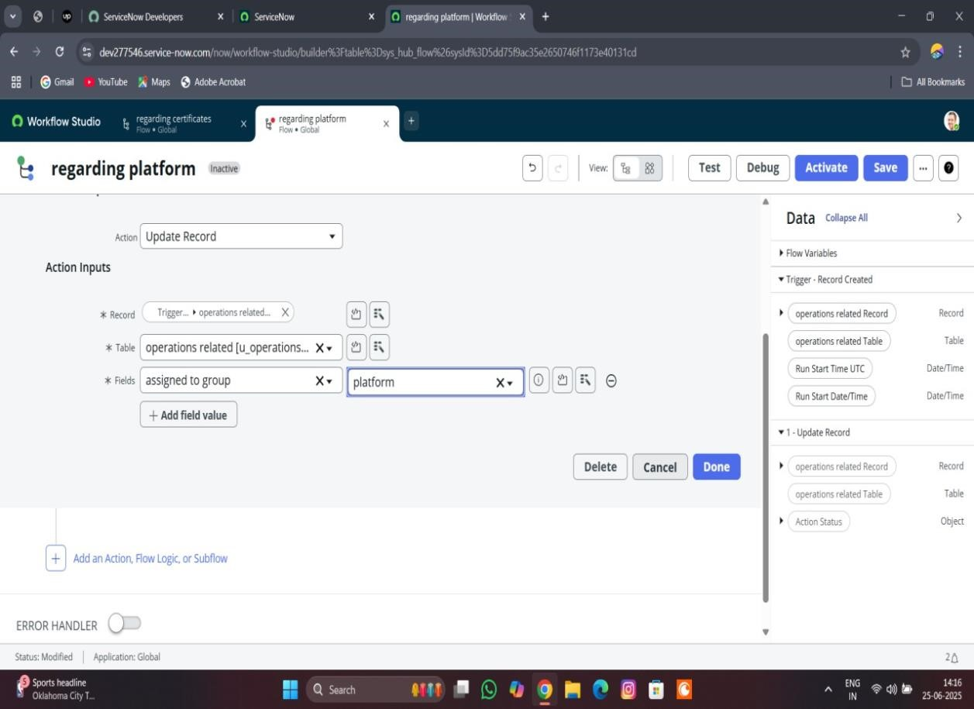

**RESULTS:**

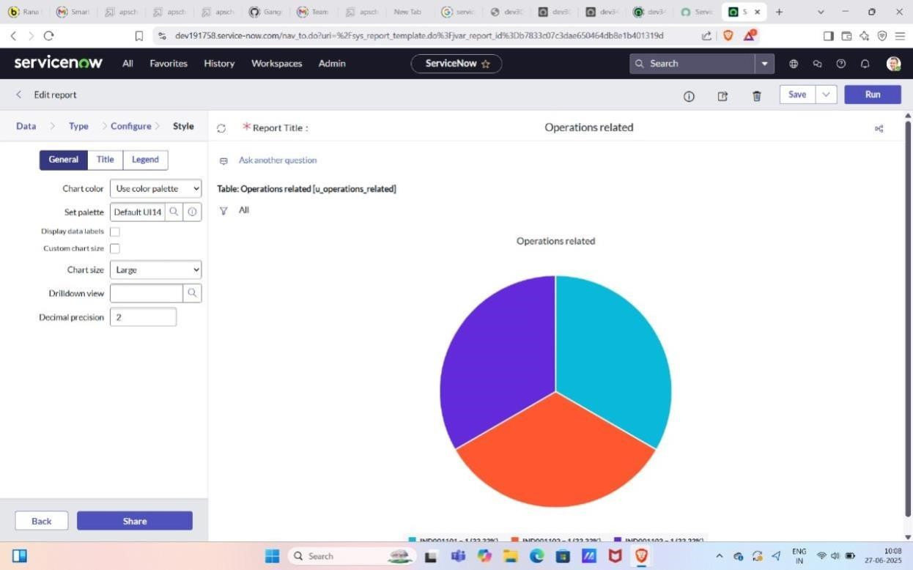

**Advantages and disadvantages**

**ADVANTAGES:**

* 1. Faster ticket response and resolution
  2. Balanced workload among support agent
  3. Improved customer satisfaction
  4. Reduced manual errors in ticket assignment
  5. Better tracking and accountability of tickets
  6. Higher agent productivity and efficiency
  7. Improved SLA compliance
  8. Easier handling of high ticket volumes
  9. Quicker identification of critical issu

10.Supports automation and smart routing

**DISADVANTAGES;**

* 1. May require complex initial setup and configuration
  2. Risk of incorrect auto-assignment if rules are not properly defined
  3. Reduced flexibility for handling unique or exceptional cases

4.Dependence on accurate and updated agent skill data

* 1. Potential over-reliance on automation, reducing human oversight
  2. System errors or misconfigurations can delay ticket resolution
  3. Can require ongoing maintenance to keep assignment rules effective
  4. May not account for sudden changes in agent availability or workload
  5. Can lead to agent dissatisfaction if workload balancing is not properly tuned
  6. Initial training and adoption may take time for support teams

**CONCLUSION:**

Streamlining ticket assignment is a critical strategy for improving the efficiency and effectiveness of support operations. By automating the process of routing tickets to the most appropriate agents or teams, organizations can significantly reduce response and resolution times. This leads to faster service delivery, ensuring that customer issues are addressed promptly, which directly enhances customer satisfaction and builds trust.

An efficient ticket assignment process also ensures that workloads are evenly distributed among agents, preventing burnout and improving overall team morale. It minimizes manual errors, reducing the chances of misrouted or delayed tickets that could impact service quality. Additionally, streamlined assignment supports better SLA compliance by ensuring tickets are prioritized and handled within the required timeframes.

Automating ticket assignment also improves visibility and accountability, as it clearly defines ownership from the start, making it easier to track ticket progress and agent performance. It enables support teams to scale efficiently, especially when handling large volumes of tickets, and lays the groundwork for advanced technologies like AI-based routing and predictive analytics.

However, it’s important to regularly review and update the assignment rules to accommodate changing team structures, workloads, and skill sets. Without proper configuration and ongoing maintenance, the system may introduce new challenges, such as incorrect routing or lack of flexibility for special cases.